

2 Minute Form
Trip Name: Glow-worm Glory – Waikato River
Check-in Name and Phone:
Date: Branch:
Leaders
Cell Phone Number
VHF Call Sign &/or Vessel Name
Vehicle make, model, registration, colour
General Plan
Note: If plan changes, you must notify your Check-in person.
Latest Time Off the Water |  |  |  |  | TMP used²⁰
Tide/ Forecast Lake Level | Low |  |  | High
Communications Carried²¹ | VHF. Cellphone only works if climb a hill, then need to ring a landline.
Communications | We will be communicating as a group on VHF Channel _____
Equipment Carried | Usual winter kayaking kit and safety gear. Head-torch or kayak white all-round light. Reflector tape on paddle or kayak.
Trip Report
(Use other side if more space required)

Activity | Kayaking – Glow-worm Glory | Centre | North Shore | Location – Waikato River |  |  |  |  | Difficulty¹ |  |  | Strong beginners
Activity Description | Morning, afternoon and evening paddle |  |  |  | Leader qualification req.² |  | Sea Kayak Leader
Get in Location | Morning: Jones Landing. Afternoon: Little Waipa Domain |  |  |  | Map no.⁴ |  | 260-T15, T16, BE35 |  | Distance |  |  | 18km
Get out Location | Morning : Jones Landing. Evening: Little Waipa Domain |  |  |  | Coastguard Channel |  | 16 |  | Nowcasting |  |  | 22, 23
Emergency get out ⁵ | Along river bank, Finlay Park, Domain |  |  |  | Emergency / Coastguard Station |  |  |  | Phone
Emergency get out ⁵ |  |  |  |  | Drinking Water⁶ | River |  | Toilets⁷ |  |  | Domain
Emergency Response | Refer Emergency Response Booklet |  |  |  |  |  |  | Parking⁸ |  |  | Domain
Specific Equipment Required⁹ | Night lights – torch or all round kayak light |  |  |  | Working Communications equipment in this area¹⁰ |  |  |  |  |  |  |  | PLB  VHF Sat Phone
Other resources  and notes¹¹ |  |  |  |  | Weather Parameters¹² | 15knot or less head wind
Previous incidents¹³

Safety Management¹⁴
Hazard |  | Significant?  - E/I/M |  | Management Strategy¹⁵ |  |  |  | Hazard | Significant?  - E/I/M | Management Strategy¹⁵
Cold Water |  | Yes - M |  | Carry spare dry clothes and shelter |  |  |  | Deep Water | Yes - E | Correctly fit PFDs
Medical Conditions |  | Yes - M |  | - Leader has first aid qualification  - Ask customers about medical conditions |  |  |  | Bad Weather | Yes - M | Understand weather forecasts.  Have back up plans or pull out if necessary
Capsizing |  | Yes - M |  | - Correctly fit PFDs  - Skills at performing rescues. |  |  |  | Heat / Sun | no - M | - Protective Clothing (worn), Sunglasses, Hat  - Sun Screen  - Plenty of drinks
Panic |  | Yes - M |  | Ensure conditions match level  of skills |  |  |  | Obstacles | Yes - M | Mai mai on river, in the dark.
Hunters |  | Yes - M |  | Avoid the first w/e of May as it is the opening of duck shooting season. |  |  |  | Other Vessels | Yes - M | - Understand the “rules of the sea”  - “Be seen” – Have two of the following; flag, brightly coloured kayak, brightly coloured Pfd or hat. At night: an all- round white light & a powerful torch.
Cold conditions |  | Yes - M |  | Camping in winter –beanie, thermals, woollies, hot water bottle advised. |  |  |  | Other Hazards
Written up by: | Ruth Henderson |  | Approved By: |  | Rob Howarth | Signed: |  |  | Date: | 5/5/2014 | Review in: | 12 months from date of approval

Additional Information Sheet (Optional)
Introduction (A general introduction)
Description (A description of the tour – as if you were selling the idea to someone)
Local Attractions |  | Transport/ Local Operators
 | Contact details |  | Contact details
Local Eateries
 | Contact details
Accommodation/ Campsite Locations |  |  | Facilities
Name | Camping at private property (Private home with camping in adjoining field. Use of house facilities inc hot showers).  Or freedom camping at Jones Landing (shade trees, flush toilets only) |  |  |  | Fuel | no
Phone |  |  | Showers | no | Power | no
E-mail |  |  | Toilets | yes | Water Access | yes
Website |  |  | Laundry | no | Pool | no
Physical Address |  |  | Water | river | Fires Allowed | Yes in winter
Other |  |  | Supplies | no
Other information

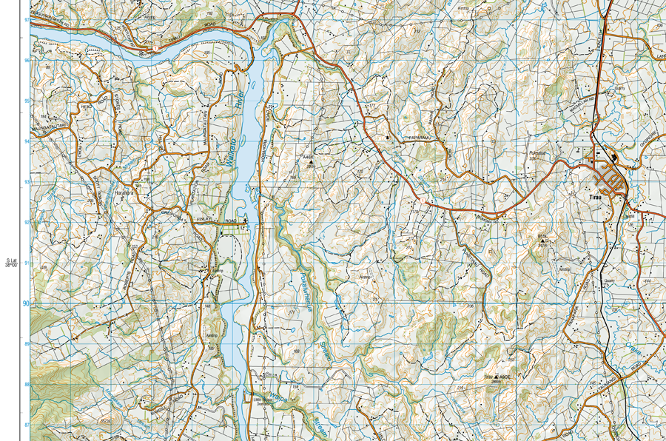

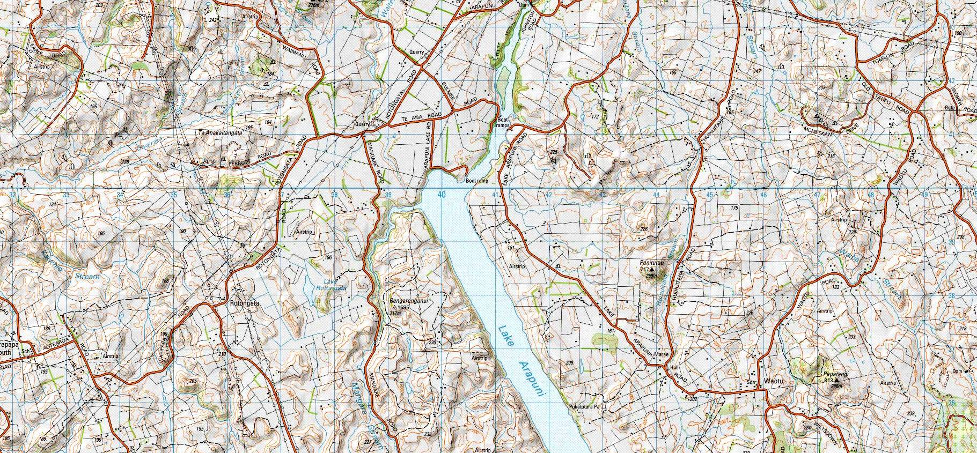

Activity Equipment Check list
Equipment List
- Helmet (rivers & surf) Group Gear
❑ Beanie / hat  Split paddles
❑ Thermals  Repair kit
❑ Paddle Jacket  Fire lighting
❑ PFD  Cooker/thermos
❑ Spray deck  Spare thermals
❑ Booties  Tow system
❑ Water & food  1st Aid Kit
❑ Kayak & paddle  Flares
Group - Oceans & Lakes  Compass
❑ Pumps & Paddle Floats  Charts / Maps
Group - River  GPS (optional)
❑ Throw ropes  Knife (cut rope)
❑ Pin kit & saw  Emergency Shelter

In case of emergency: Dial 111, Mayday :VHF Channel 16

Kayaking Check list

❑ Trip plan
❑ Latest weather forecast
❑ Conditions match skills?
❑ Hyperthermia (hot) &
Hypothermia (cold)
❑ On & off water safety
❑ Environmental concerns
❑ Emergency Procedures include emergency get out.
❑ Working communication devices
e.g. VHF radio, mobile phones, PLB
❑ Specific safety issues for this trip
❑ Participant list
❑ Any medical conditions
❑ All participants keen to proceed?

❑ Trip Plan/ 2-minute form lodged with Ops. Manager

Appropriate wind conditions to run trips:
Novice - no significant surf or swell, wind under 15knots
Intermediate- surf or ocean swells less than 1.5 meter or wind under 25 knots.
Advanced- any condition that is suitable to the trips aims

At conclusion of trip:
Contact check in person
Group Debrief.

Check in Person Ph:
__________________ Mobile
__________________ Work
__________________ Home

Activity Document Cover Sheet

Activity:
Date of Activity:

Activity reports. Is all relevant information present:
– Approved Trip Management Plan (TMP)/ 2 minute form
– Club Trip Participant Sheet
– Weather forecast
– Activity Check List
– Trip report (May be on the 2 minute form)
– Accident / incident reports
Leaders Signature:
Date:

